[***College Election System***](http://1000projects.org/college-election-system-java-project.html)

**Abstract:**

“College Election System” is a web application developed in java. This application provides an easy and simple way to both administrator and voters in the collect election process. In this application, voters can give their votes to college from anywhere and at any time. The administrator can add all the details of the candidates with the selected department.

The administrator can view all the details of the candidates and if necessary he can delete the details of the candidate. In this application, all the details of the voters can be view in a graph form which makes the work of the administrator easy in analysing the votes.

**Existing System:**

In the existing system, college election process takes a lot of physical effort and needs a lot of paperwork which sometimes may lead to data mislead. All the details of the election are stored in records.

Take much time and effort to analysis, calculate and finalize the result. No proper information is available.

**Proposed System:**

The proposed system all the data related to elections in the college is done online from anywhere and at any time. No physical effort and paperwork are needed. There is no chance of displacement of the data. Analysing and calculating the results is made very easy and accurate.

All the information about voters can be viewed by the administrator and can be accessed easily whenever needed.

**UML Diagrams:**

**UseCase Diagram:**

[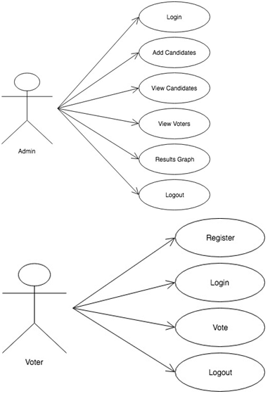](http://1000projects.org/wp-content/uploads/2018/05/College-Election-System-Use-Case-Diagram.png)

**Sequence Diagram:**

[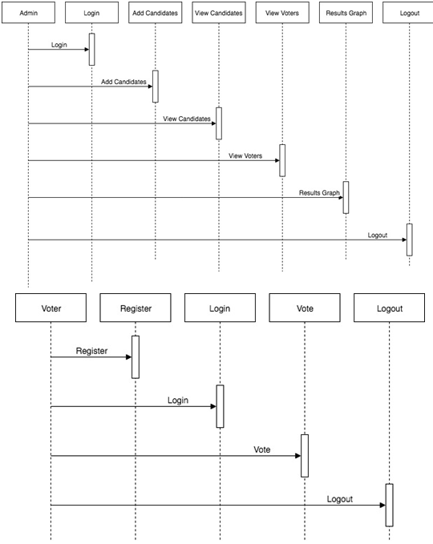](http://1000projects.org/wp-content/uploads/2018/05/College-Election-System-Sequence-Diagram.png)

**Activity Diagram:**

[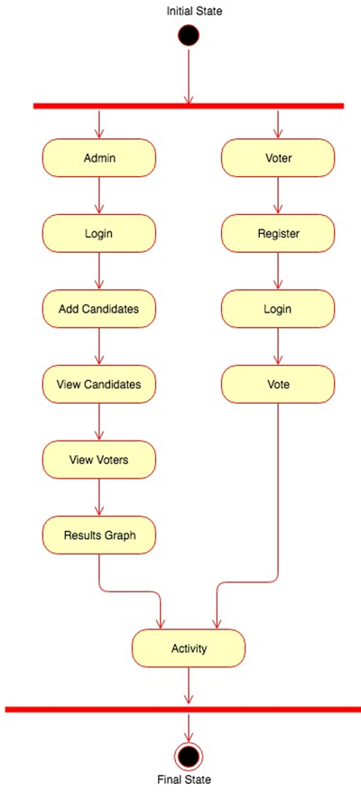](http://1000projects.org/wp-content/uploads/2018/05/College-Election-System-Activity-Diagram.png)

**Class Diagram:**

[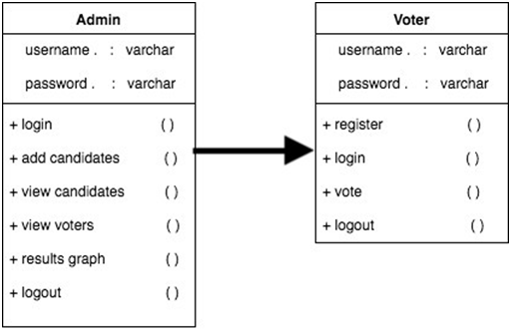](http://1000projects.org/wp-content/uploads/2018/05/College-Election-System-Class-Diagram.png)

**Modules:**

**Admin:**

Admin can get logged into the application by entering valid credentials. Admin can add candidates. Admin can view all the details and can delete the details of the candidates. Admin can view the details of the votes and result graph.

**Voter:**

Voters can need to get registered with the application by entering all the details in the registration form. The voter can get logged in to the application by entering unique username and password. The vote can fill all the details to give his/her vote.